EECS 2311

VENN DIAGRAM APPLICATION

User Manual

**By:** Mahamed Hassan - 216536476

Derui Liu - 215608946

Thanh Nguyen - 213507231

Esra Kastrati - 215507205

**Group 10**

**User Manual**

**How to get started:**

Java 8 or above is required to run this program. You can download it here: <https://www.java.com/en/download/>

To run the program, double click the .JAR file. If that doesn't work, open a terminal in the same directory of the .JAR file. Then enter “java -jar venn.jar” or the current name of the .JAR file if it has been renamed.

The program will open and you are now ready to add your data to the Venn diagram. Currently, there is no way to save the Venn diagram beyond taking a screenshot of the program.

1. If you want to add to the left set you can create your list item and then drag it to the left set of the Venn

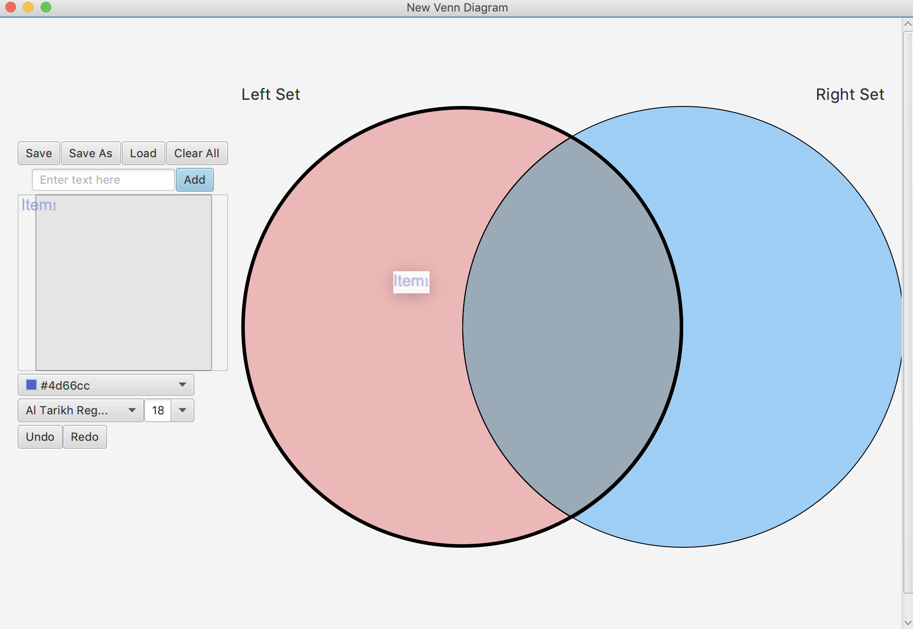

1. You can also add to the middle or to the right set, yo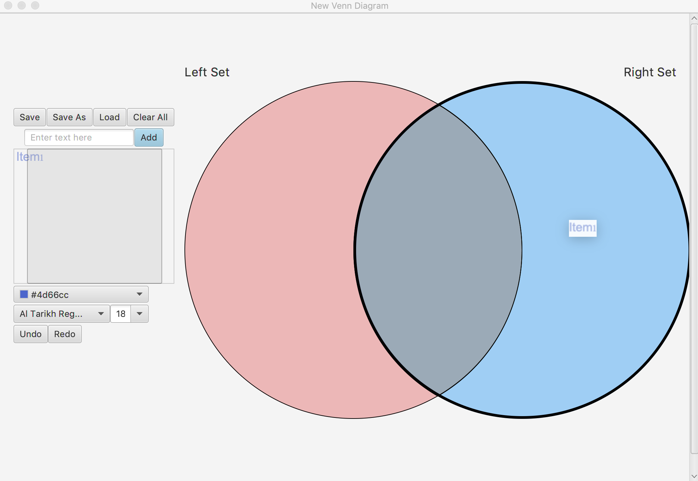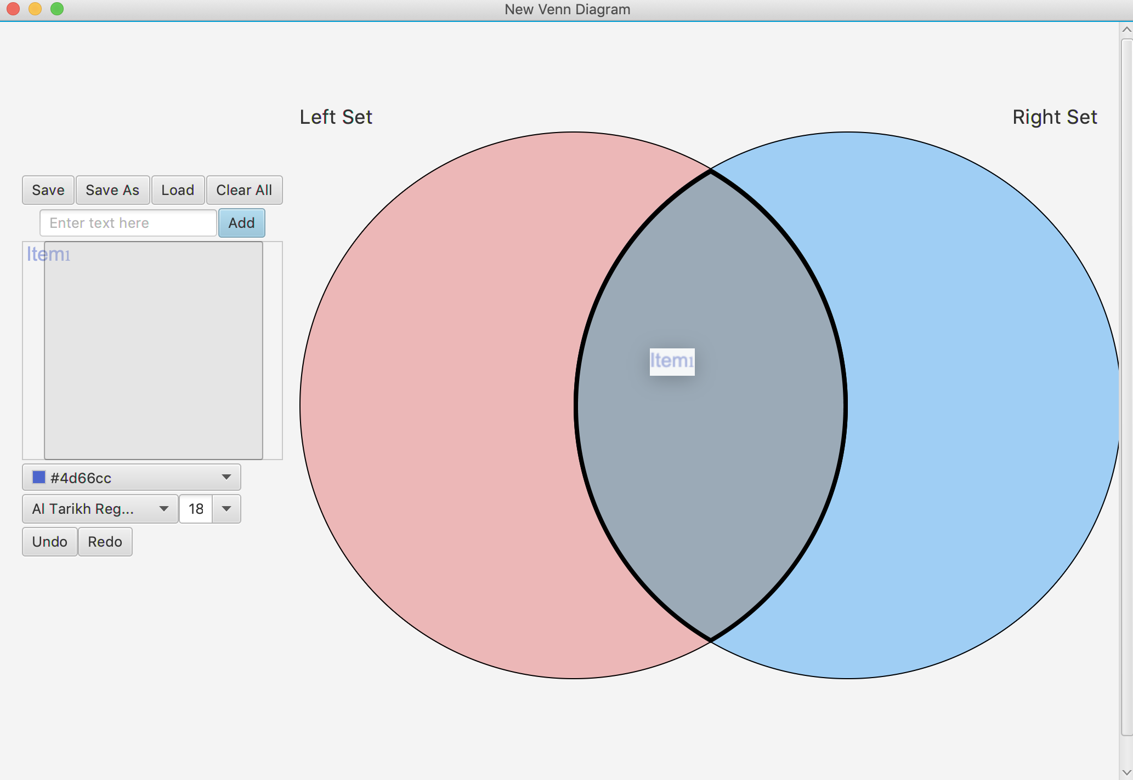u can do so by dragging and dropping, same as before.
2. To rename a set, you can right click on that set. Once you have right clicked on it, a list of two options appear on your right, click on “Rename” to change the name of that set to anything. A window pops up where you can type into a textbox, and click on “Ok” once you are done renaming the set.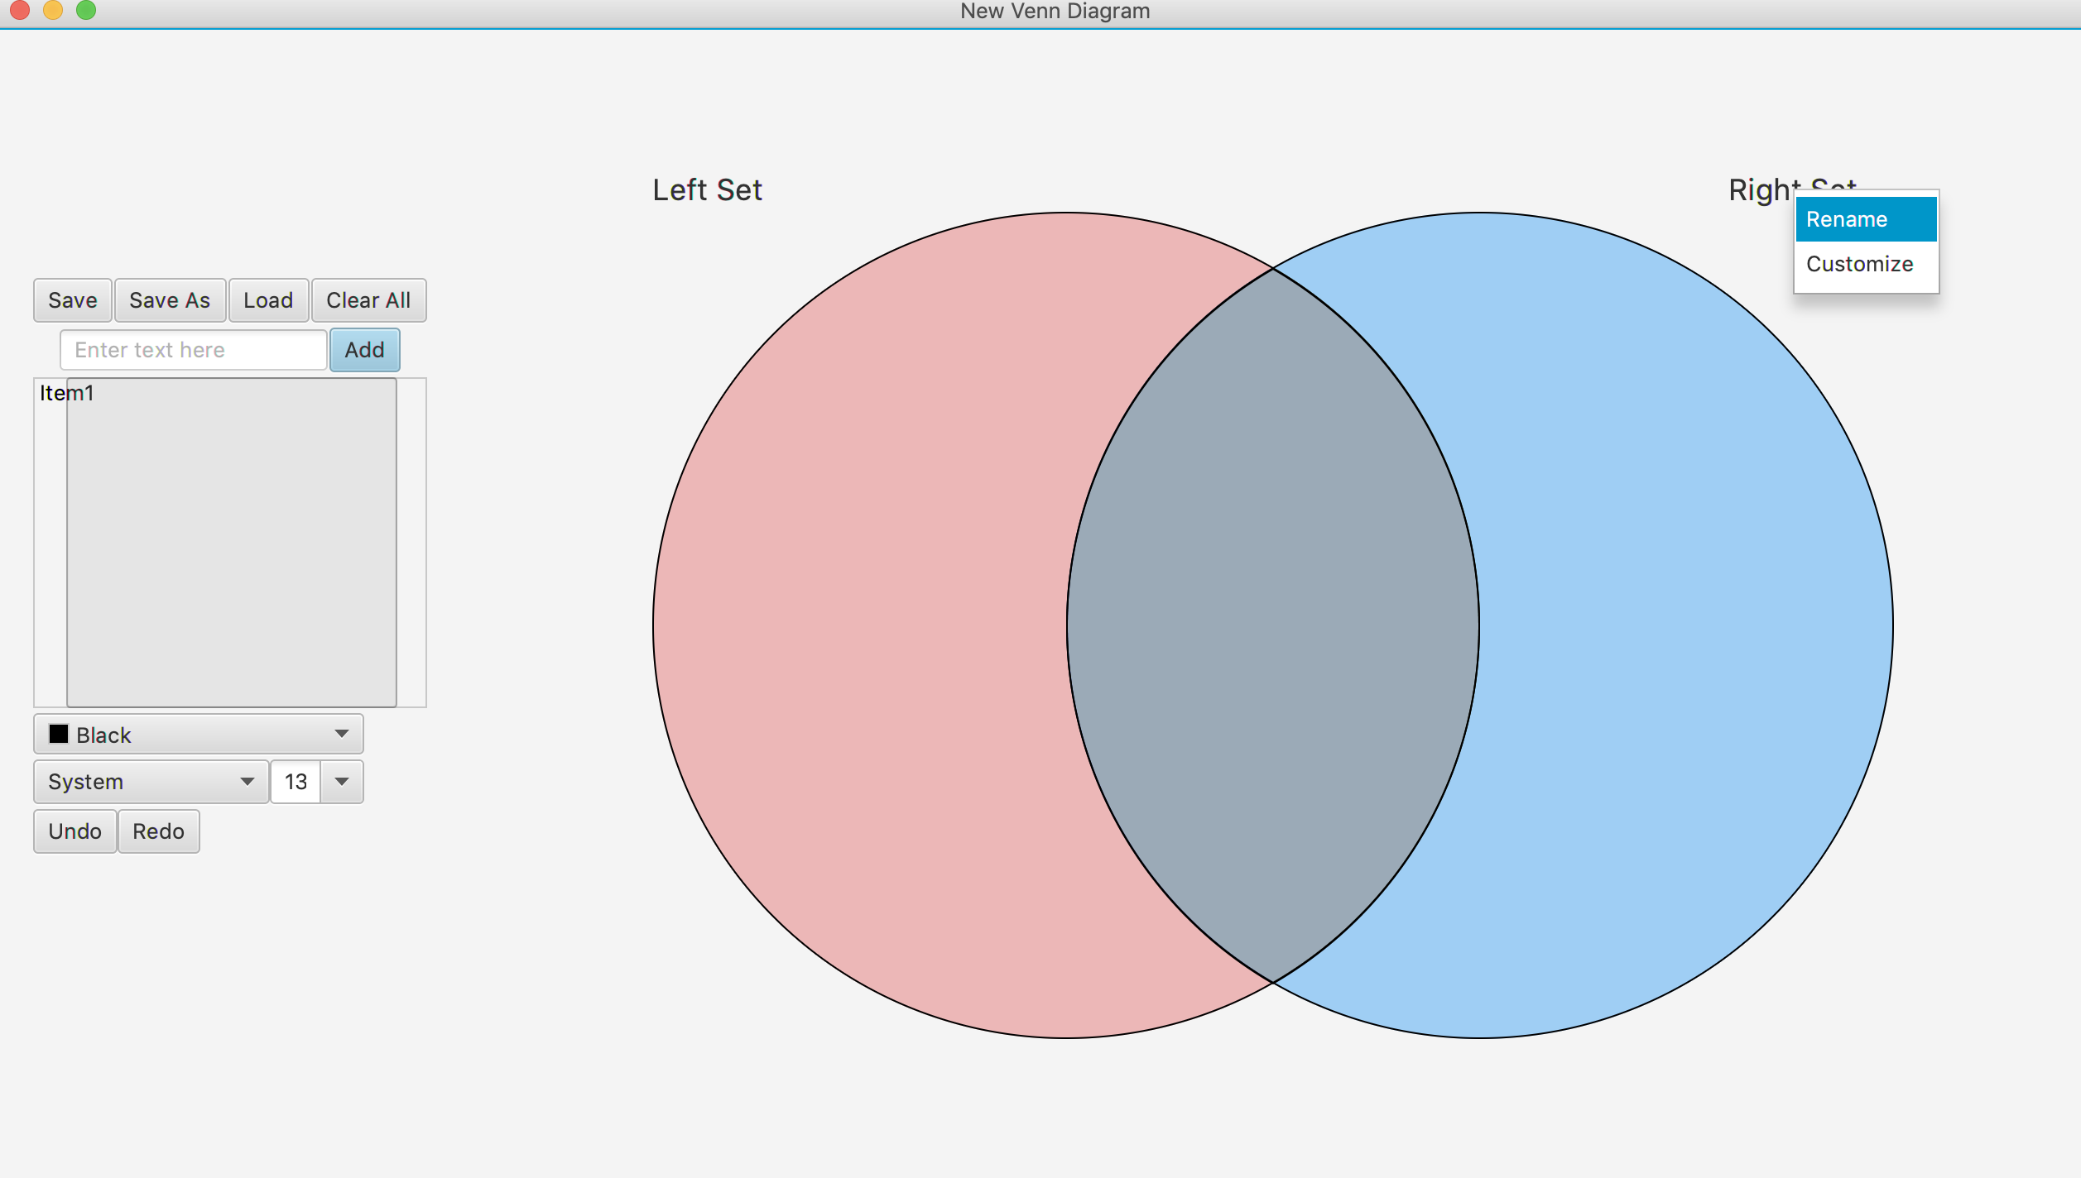

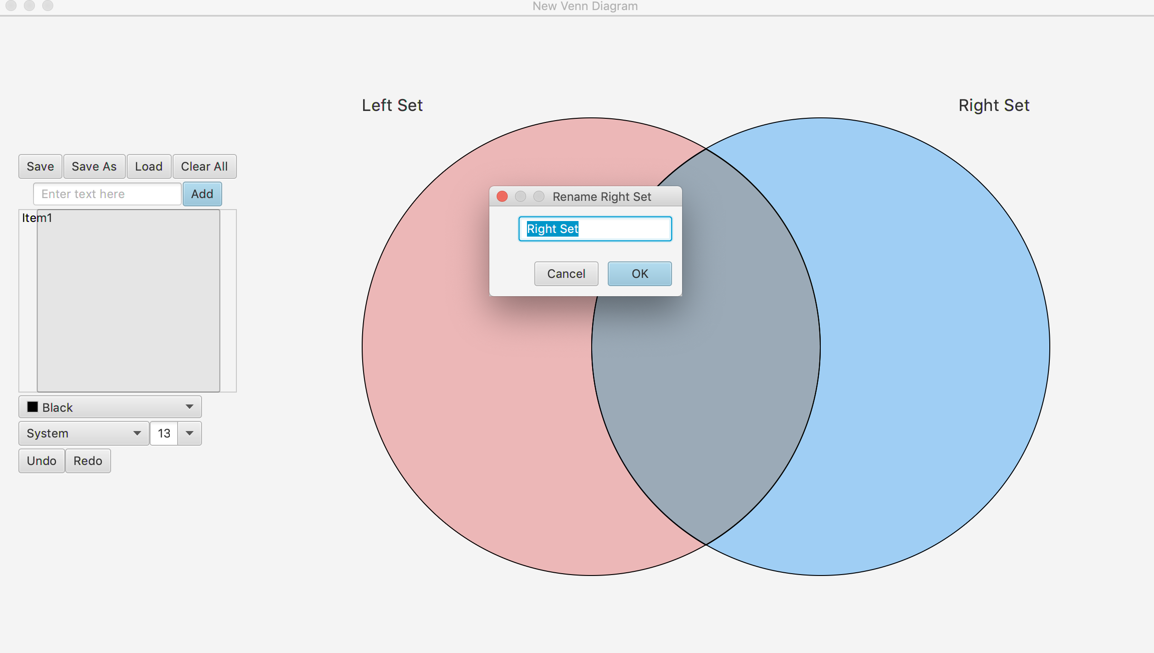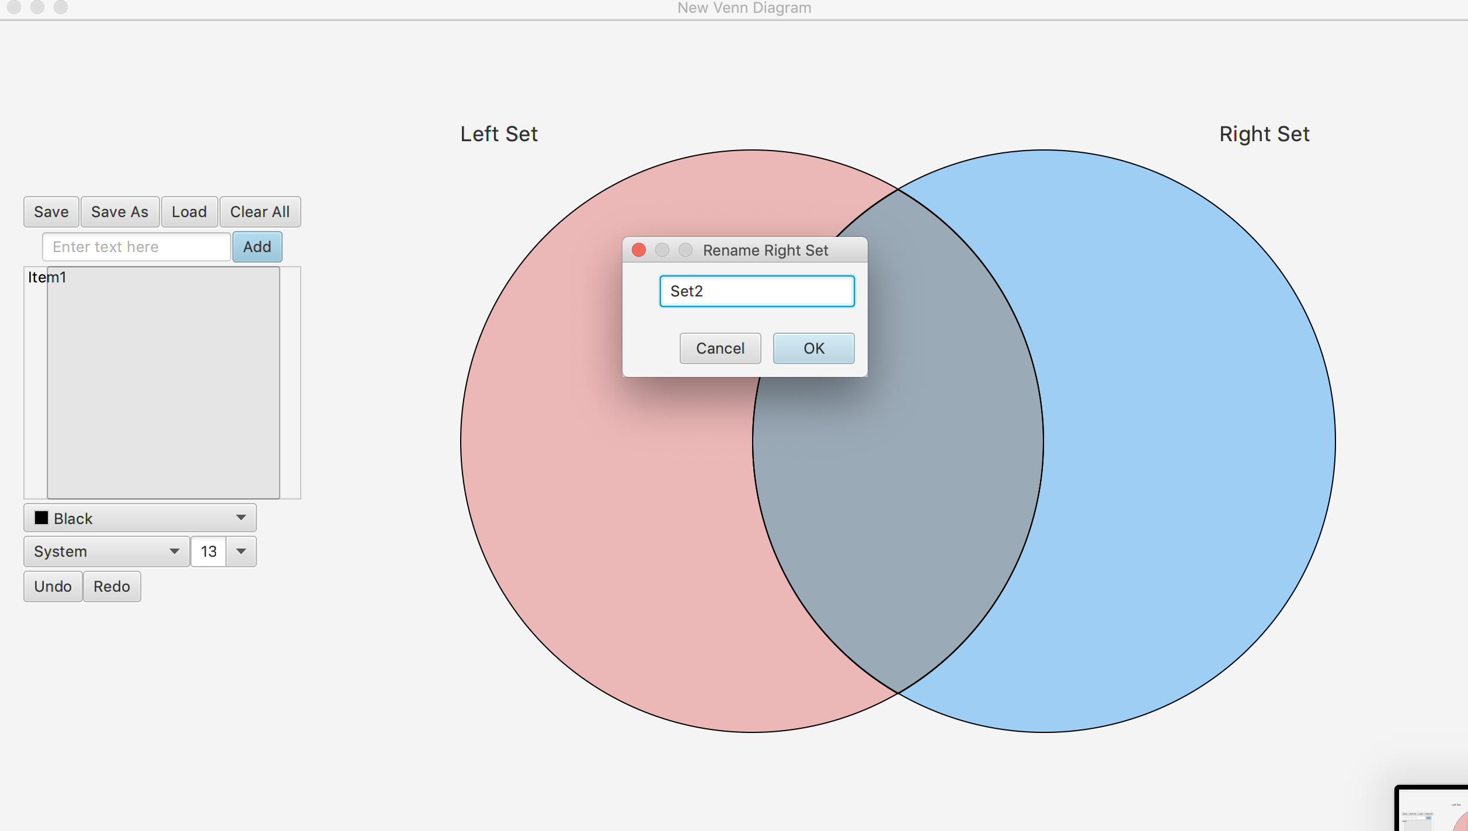

4. To customize a set, you can right click on that set. Once you have right clicked on it, a list of two options appear on your right, click on “Customize” to change the font, colour or size of the name of the set.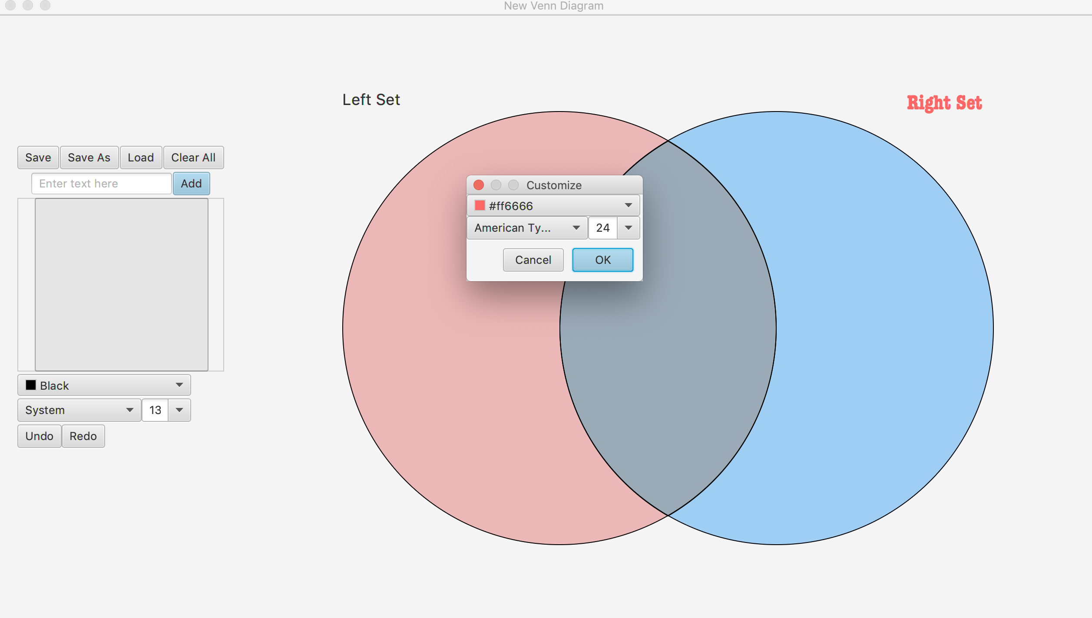

1. To rename an element from a set, go to whichever set the element is in and right click on that element, a list of options appear on your right, click on Rename to edit it. A different window will pop up with a textbox to write in, once you are done click “Ok”. The element is now renamed and edited.

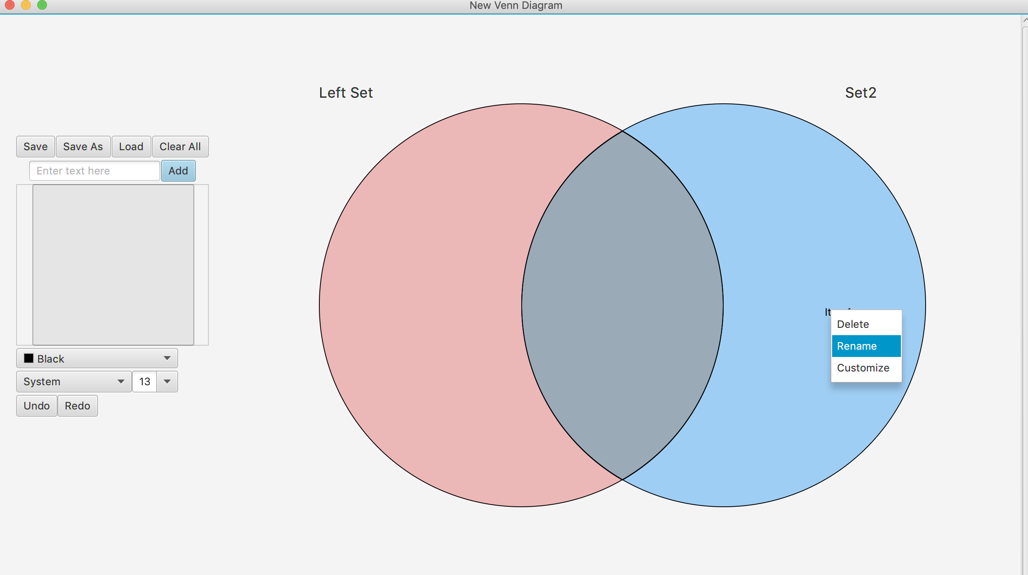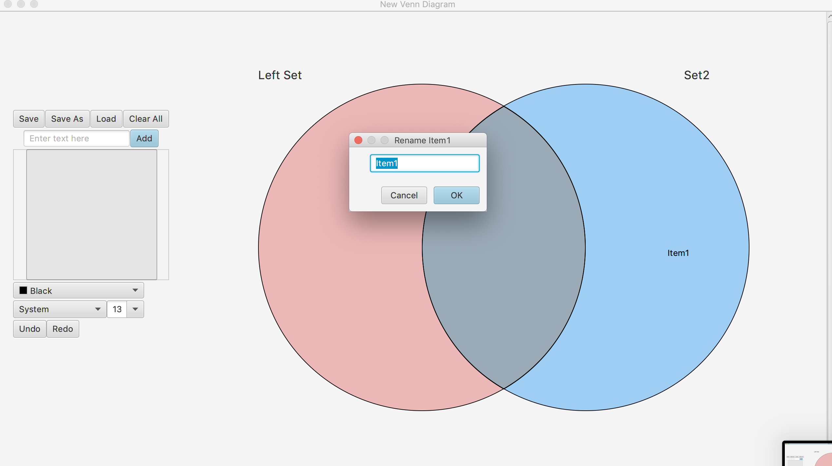

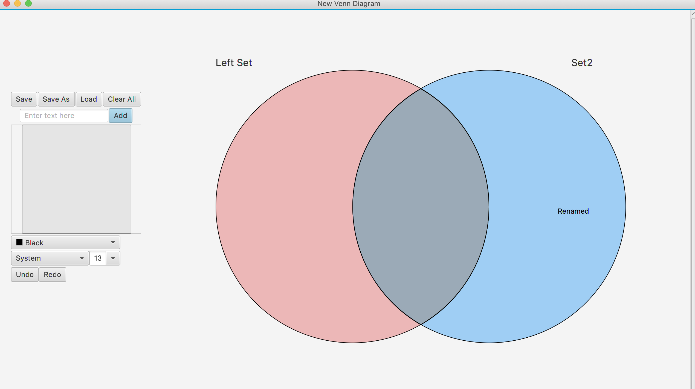

1. To customize an element, you can right click “Customize” to change the font, colour or size of the name of the element.

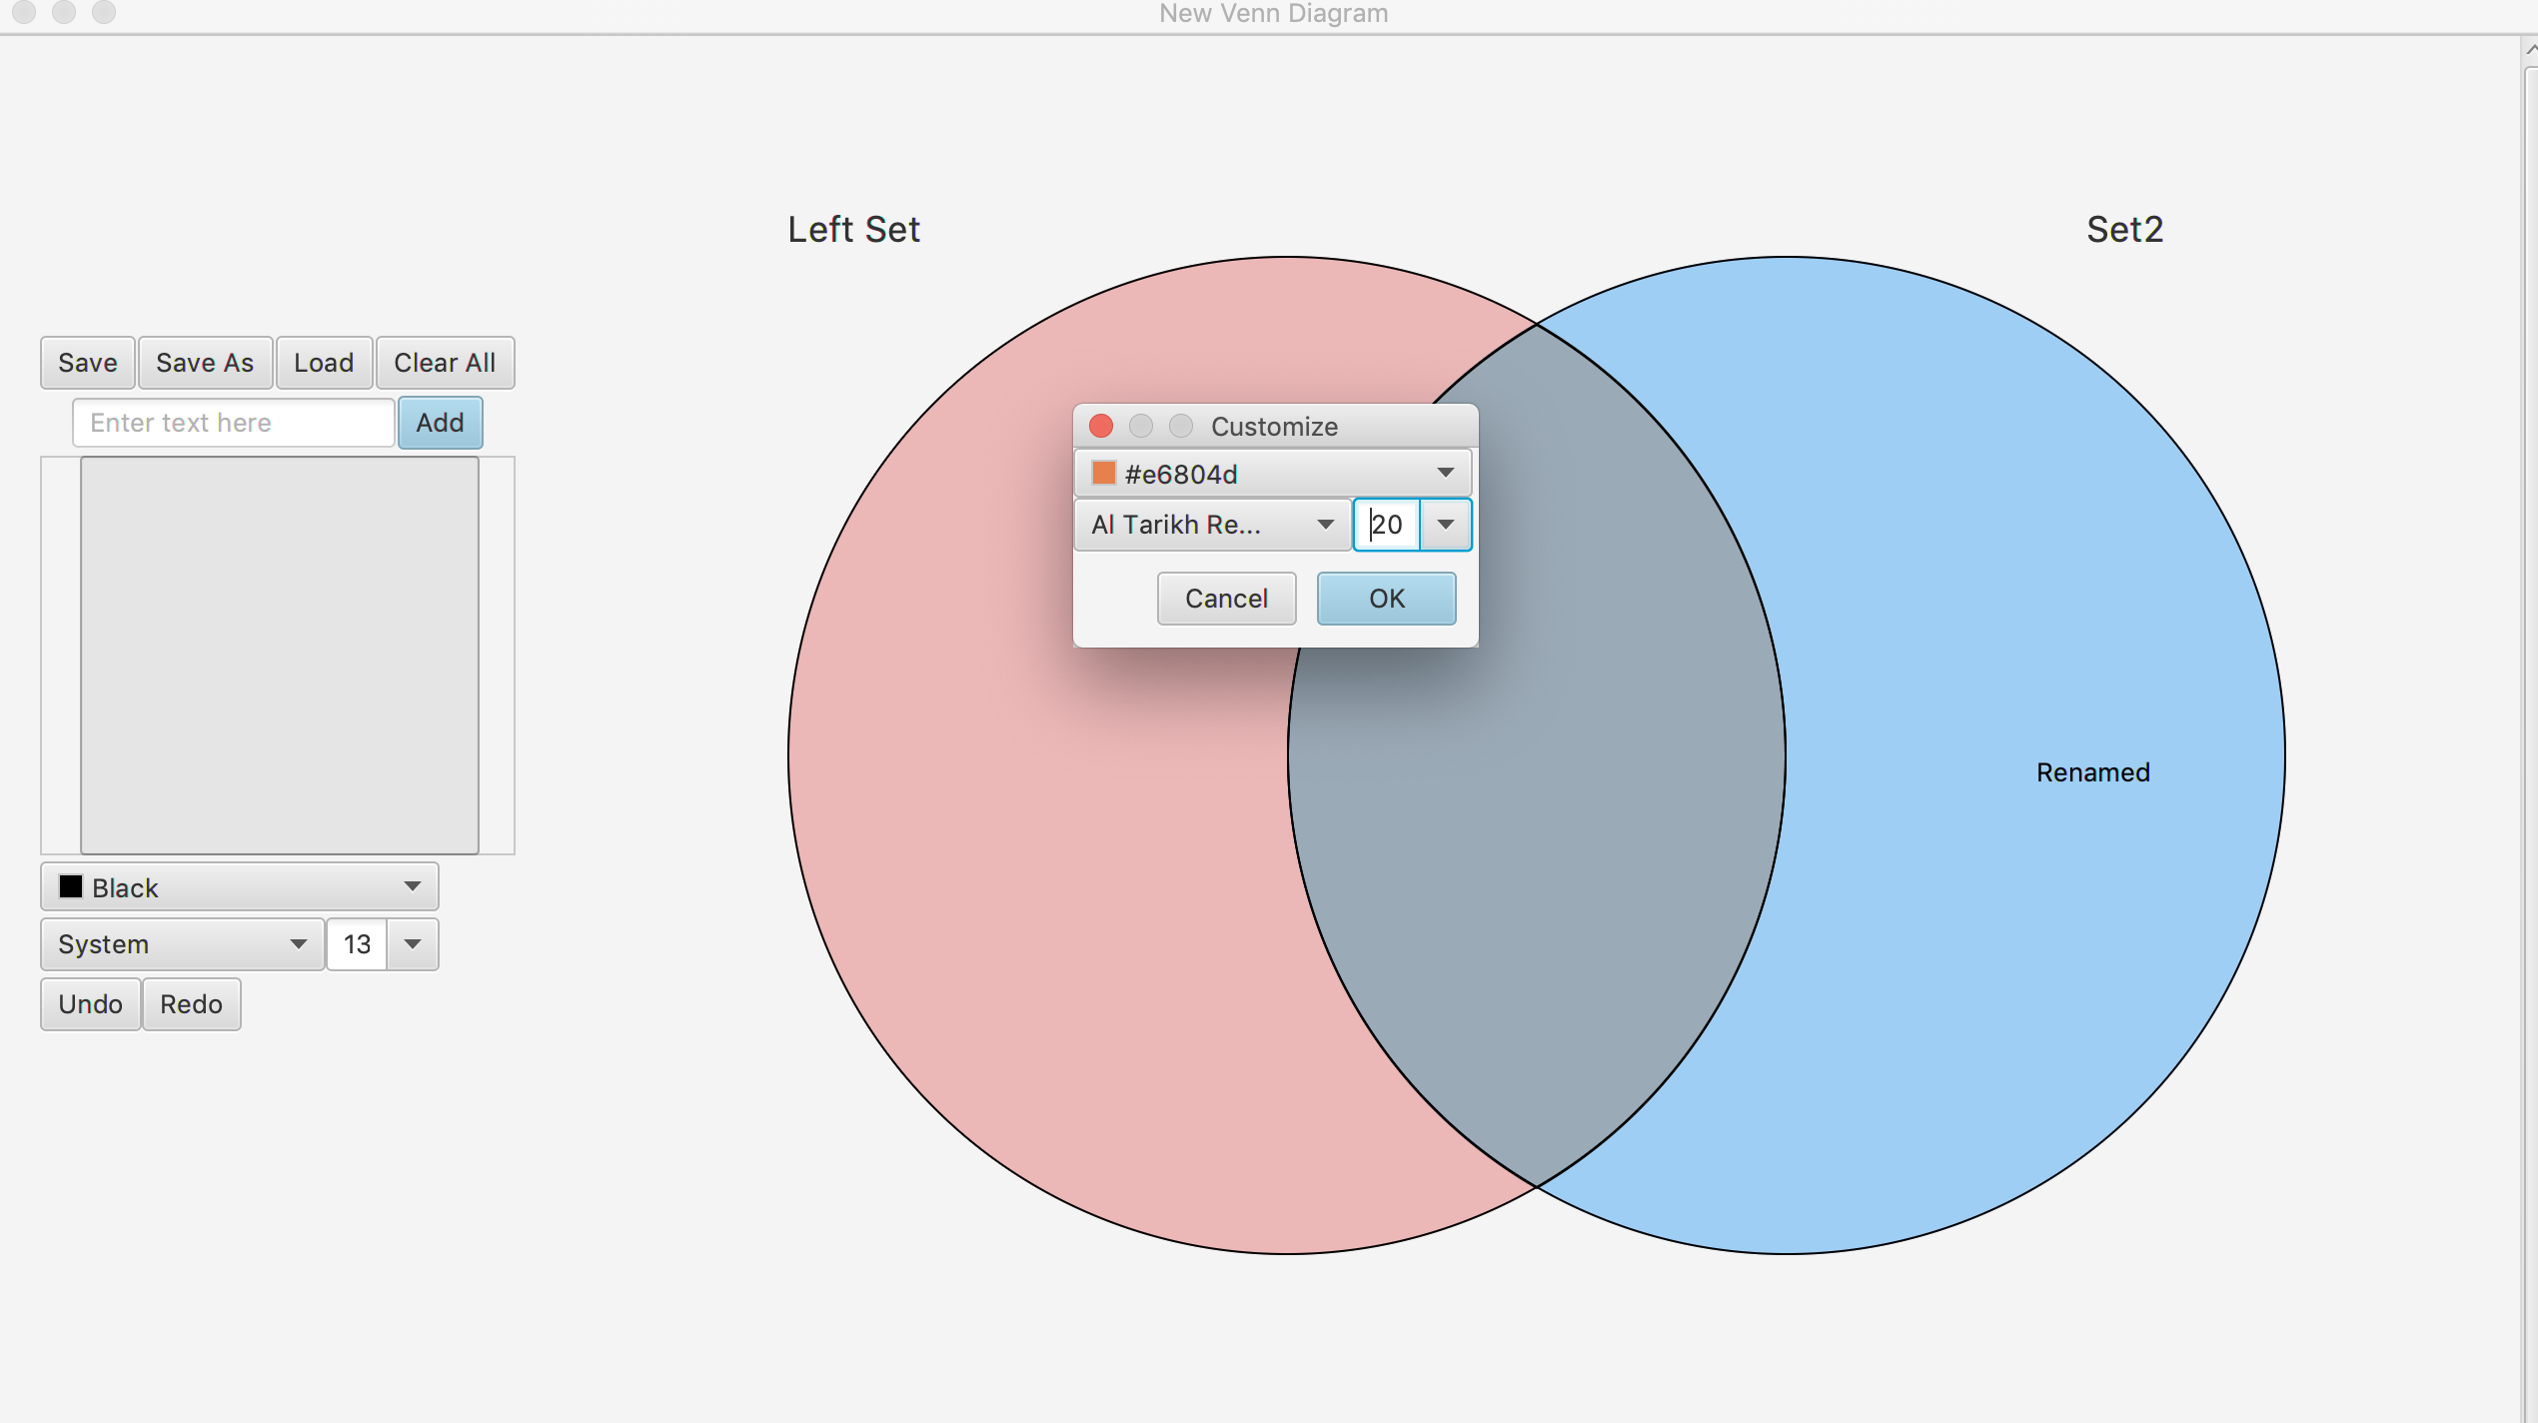

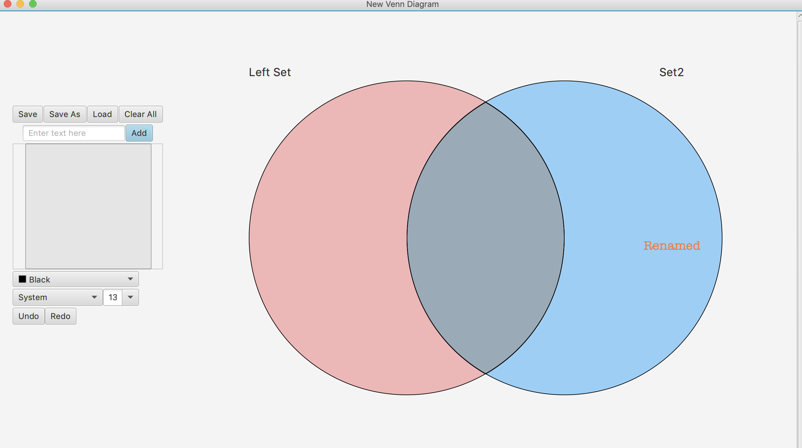

1. If you want to completely get rid of that element, you can click on “Delete” and a window will pop up asking you if you are sure you want to get rid of that element, click “Yes” and the element gets deleted.

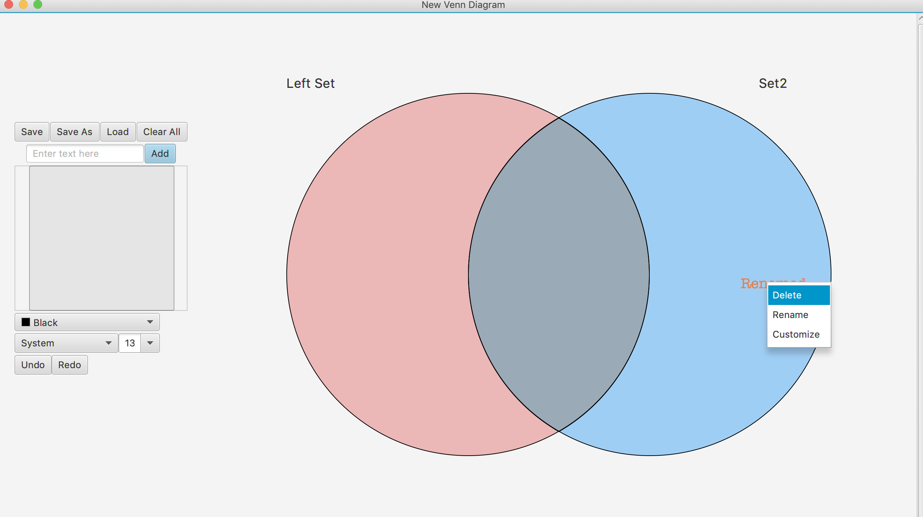

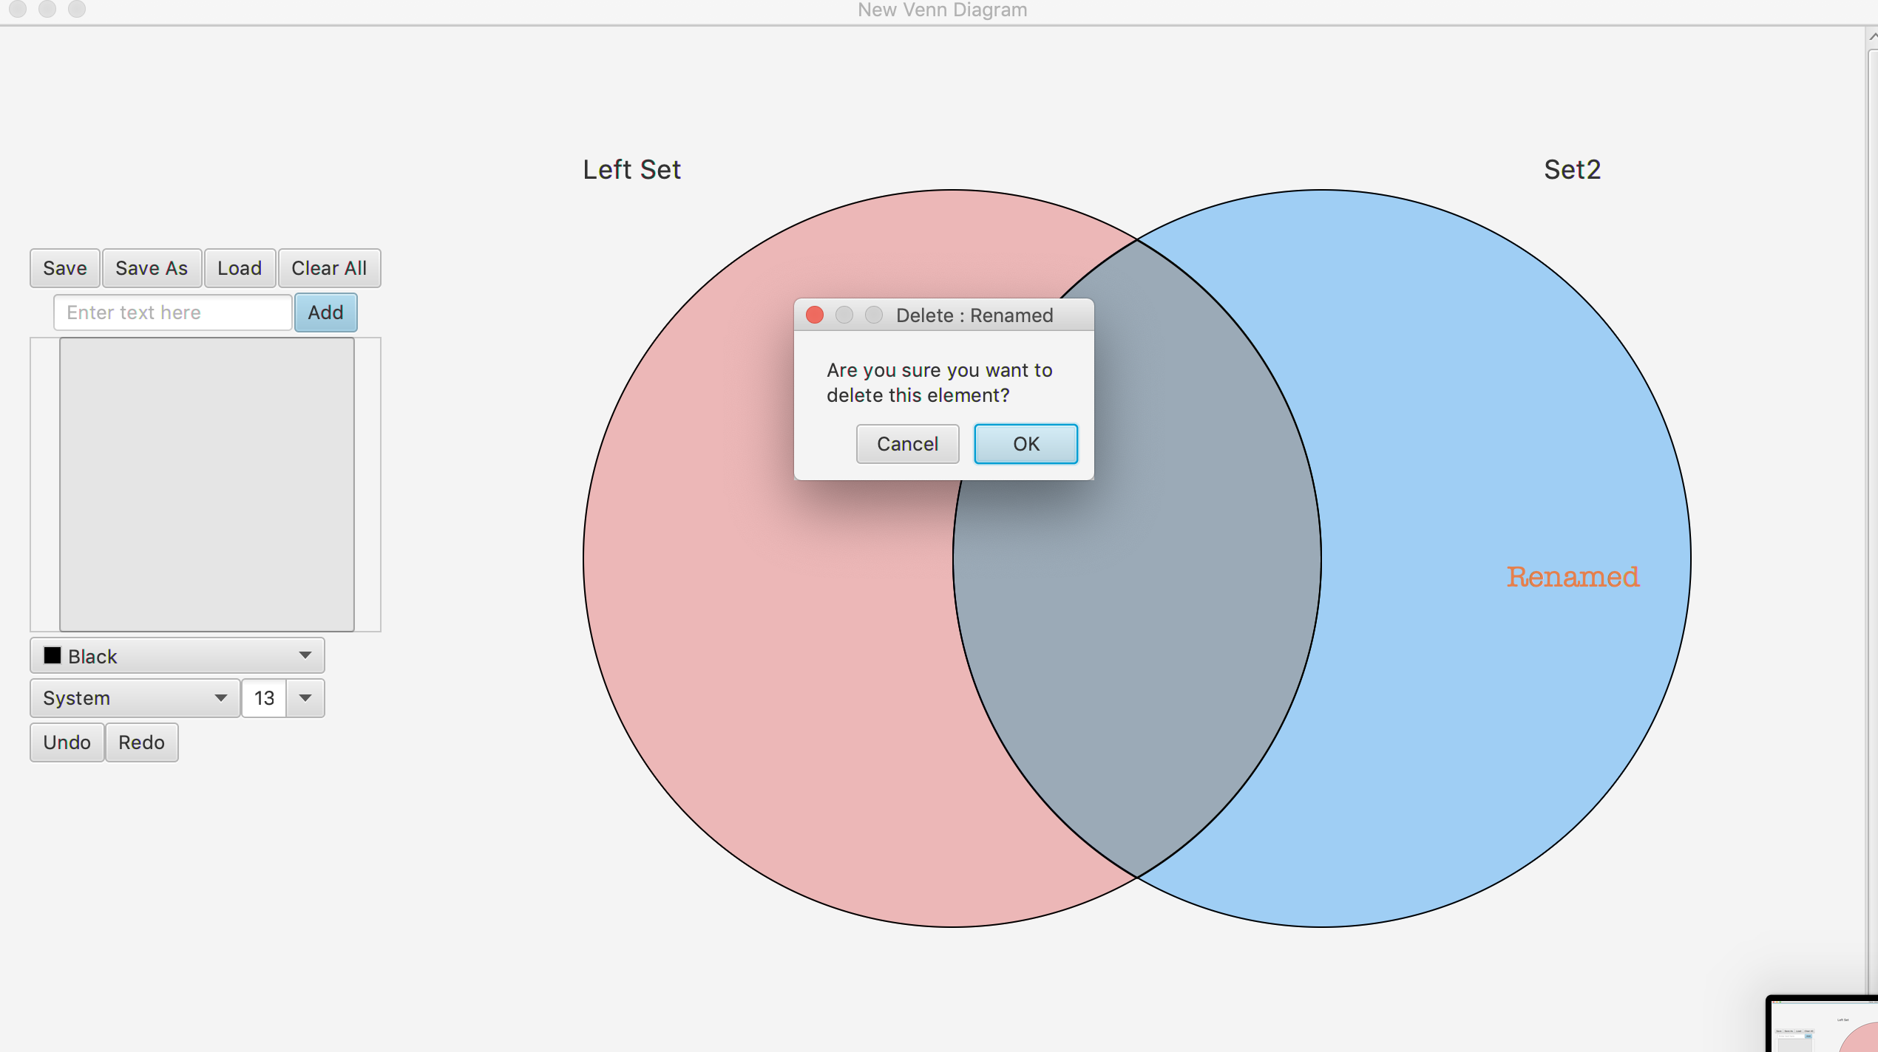

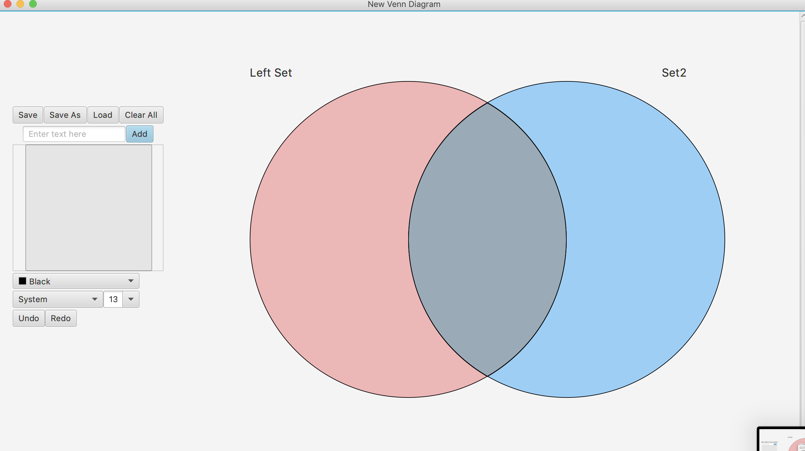

7. If you want to clear every element then you can do so by just clicking “Clear All” on the table to your left and a window will pop up asking you if you are sure you want to get rid of all elements, click “Yes” and the elements get deleted.

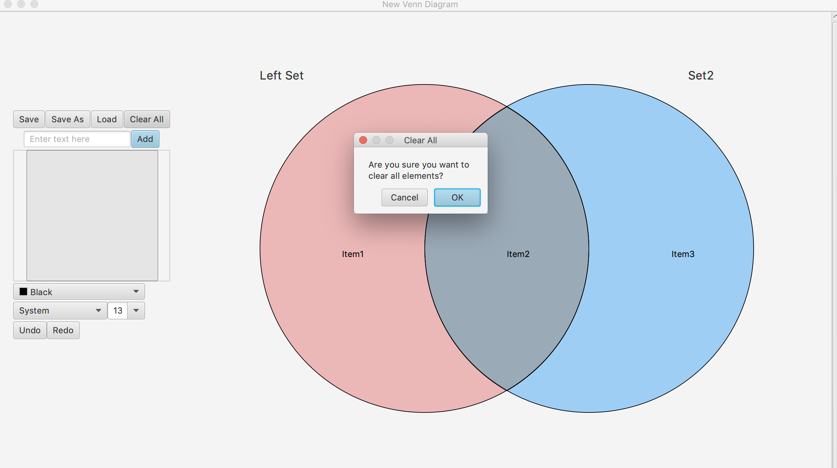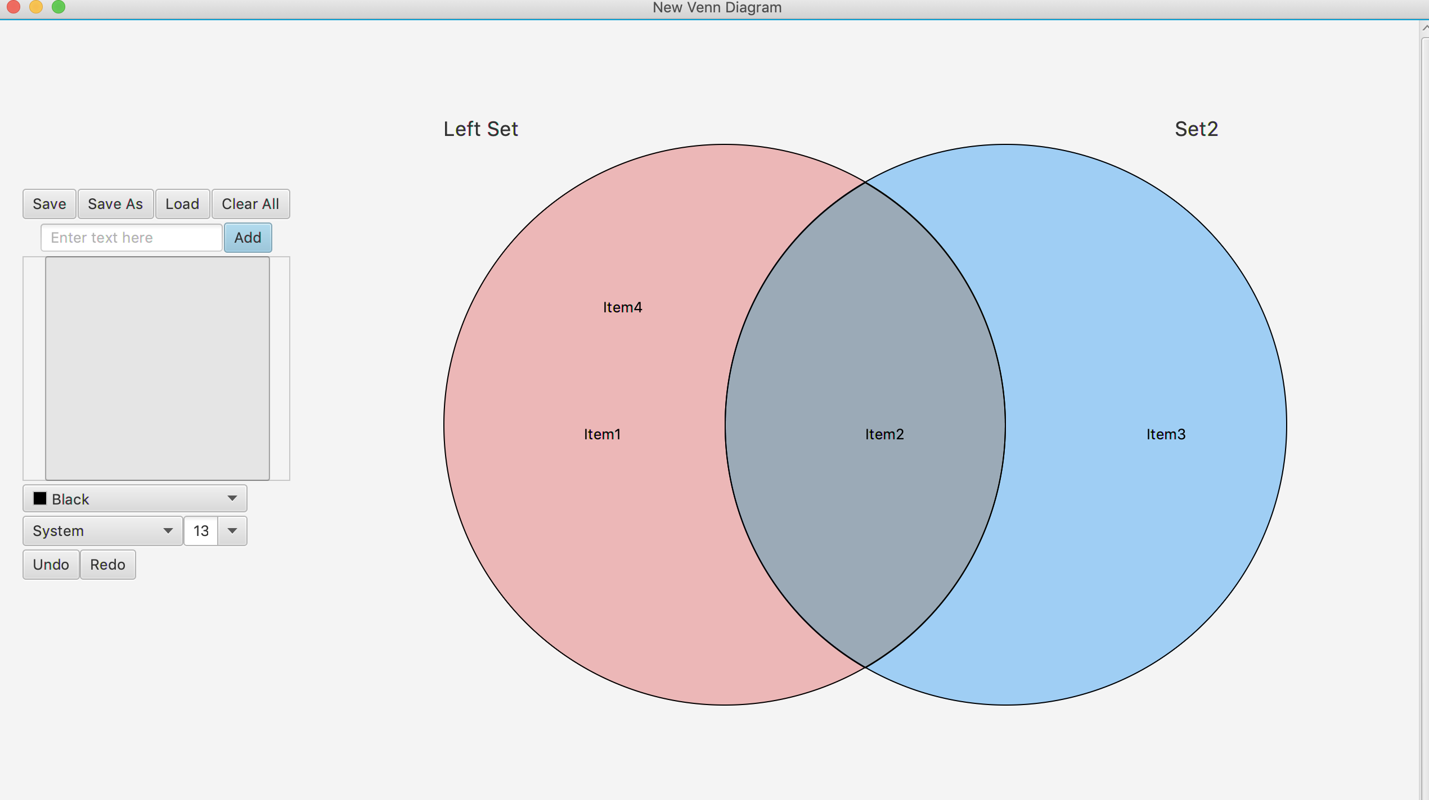

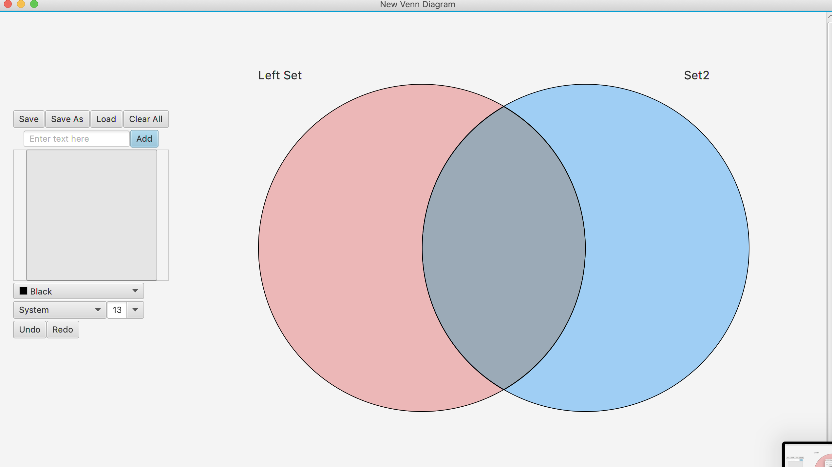

8. But if you change your mind, you can use the button “Undo” which will undo any action that you did. In our case, when I press “Undo” all elements that were deleted will reappear on the sets as they were before.

9. You can also “Redo”, by just pressing the “Redo” button. By pressing redo our last action will be processed again. In our case, all element will e re-deleted.

10. If you are done with your Venn diagram and you want to save it. You can do so by simply pressing “Save” button. A window will appear asking you for the name and location you want the Venn to be saved.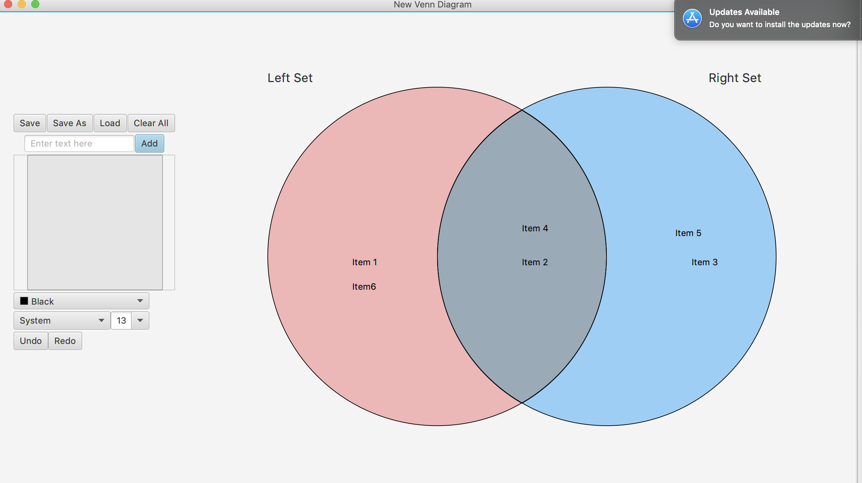

11.If you want to store a new Venn or to store an existing Venn to a new 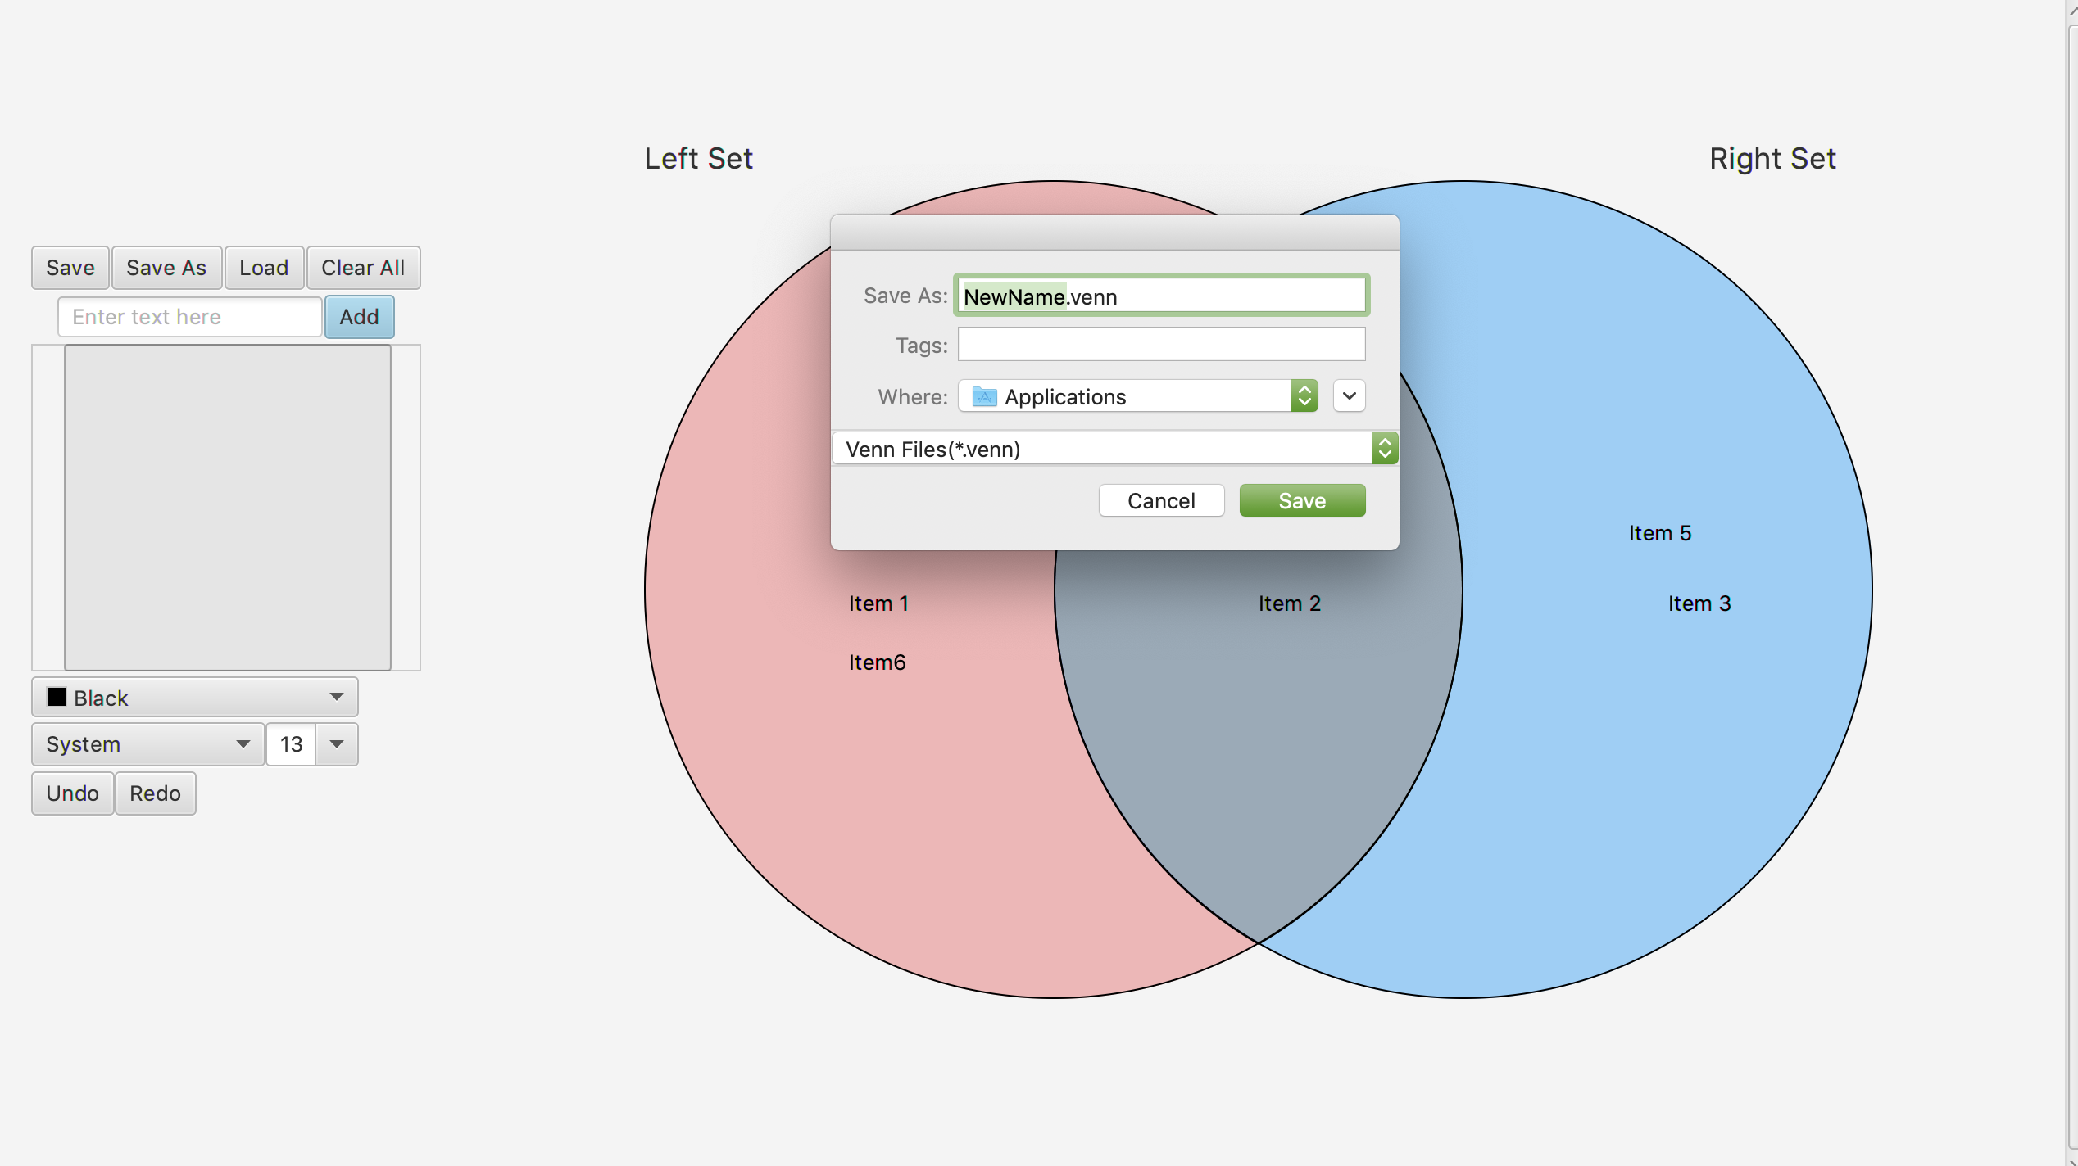location with the same name or a different name then you can use Save As.

